SPRING — ANSYS Static Structural Report
Project setup and solved results for the helical spring model (SPRING.wbpj + result plots)

1. Overview
This report covers the archive spring.zip, which contains the ANSYS Workbench project file (SPRING.wbpj), the source CAD geometry (spring.STEP), and four exported result plots (total deformation, equivalent elastic strain, strain energy, and equivalent/von-Mises stress) from a single Static Structural analysis. Unlike the project file alone, this archive includes the solved output, so this report presents both the model setup and the computed results — along with a data-quality flag on the results (Section 5).

2. Project & Geometry
Project file | SPRING.wbpj
ANSYS version | 2026 R1 (Student)
Analysis type | A: Static Structural
Geometry source | spring.STEP (STEP AP203, units: millimeters)
Material | Structural Steel (ANSYS default library)
Solve timestamp | 08/22/2026 01:24 (per project log)
The geometry is a coiled helical compression spring of several turns, meshed and solved as a single solid body.

3. Analysis Workflow
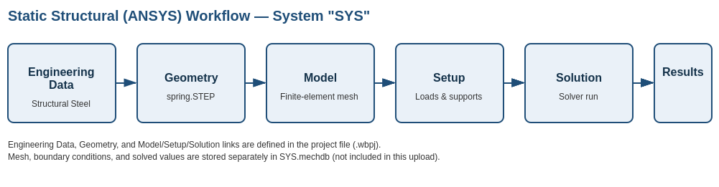

4. Solved Results
The four exported plots below are taken directly from the ANSYS Mechanical results viewer (Time: 0 s).

4.1 Total Deformation
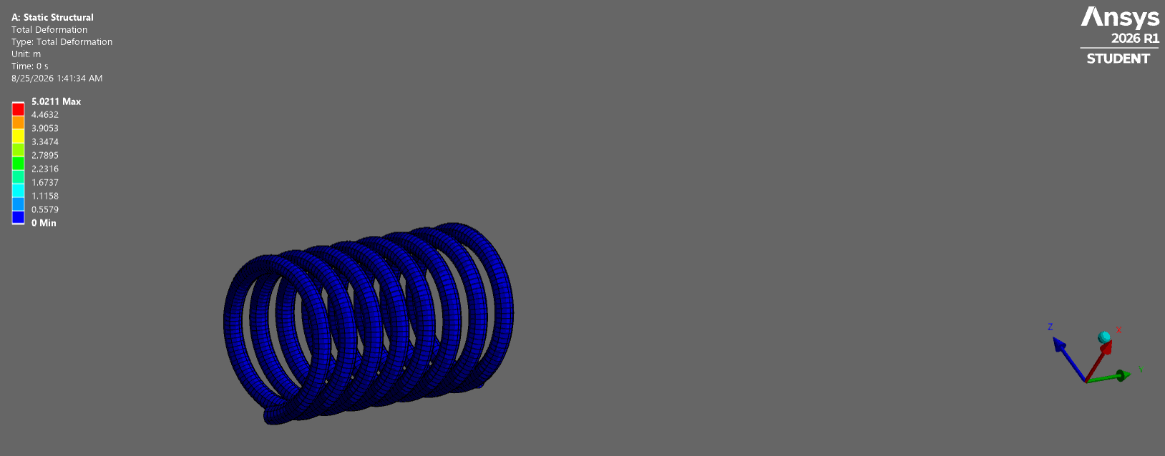
Figure 1 — Total Deformation, Static Structural (Unit: m)
Maximum | 5.0211 m
Minimum | 0 m

4.2 Equivalent Elastic Strain
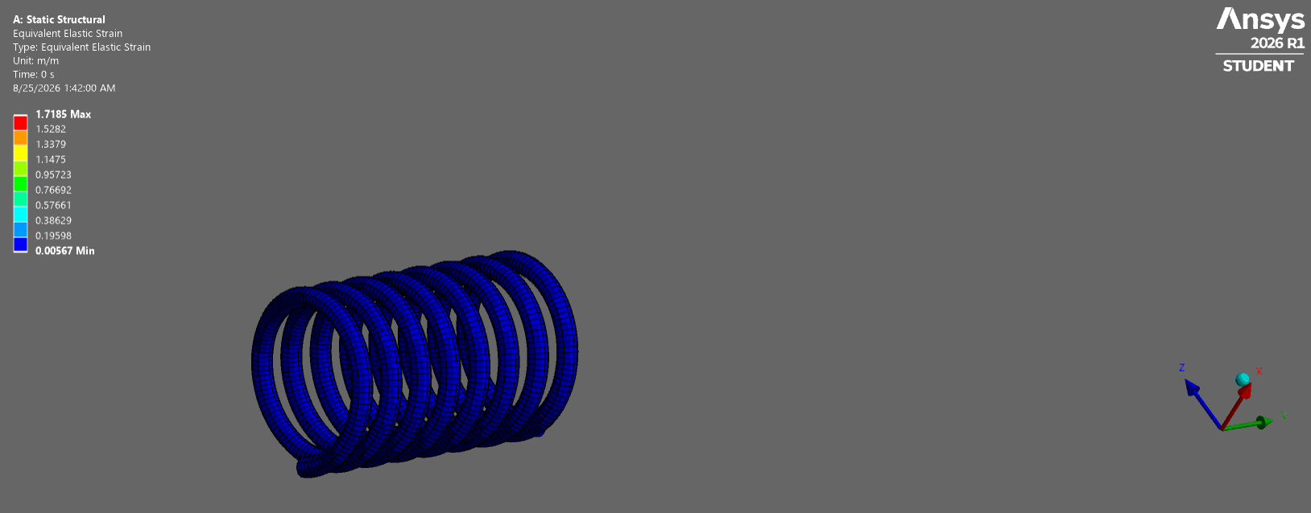
Figure 2 — Equivalent Elastic Strain (Unit: m/m)
Maximum | 1.7185 m/m
Minimum | 0.00567 m/m

4.3 Strain Energy
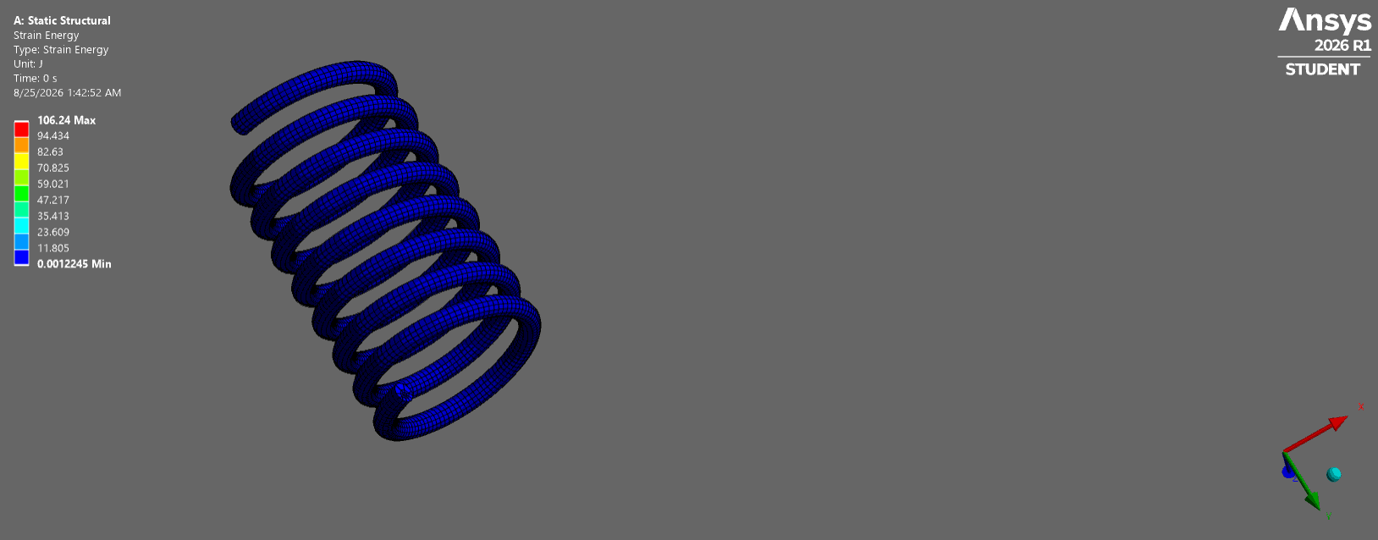
Figure 3 — Strain Energy (Unit: J)
Maximum | 106.24 J
Minimum | 0.0012245 J

4.4 Equivalent (von-Mises) Stress
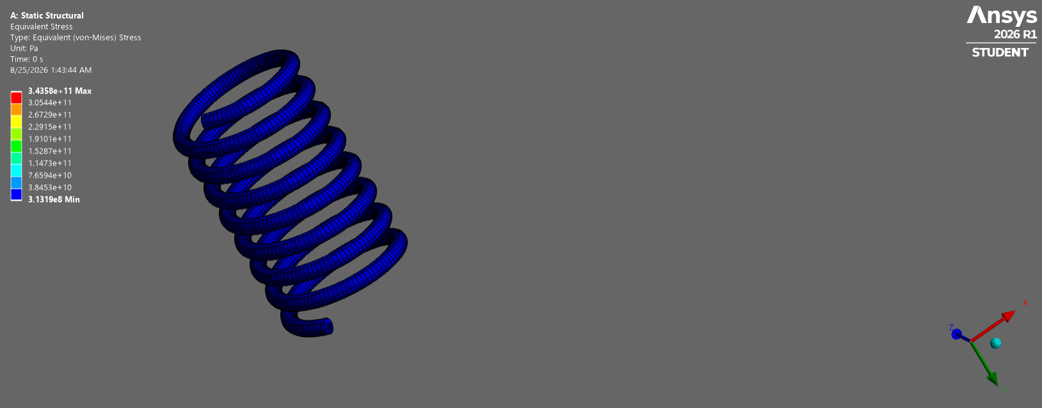
Figure 4 — Equivalent Stress (Unit: Pa)
Maximum | 3.4358 × 10¹¹ Pa (≈343.6 GPa)
Minimum | 3.1319 × 10⁸ Pa (≈313.2 MPa)

5. Data-Quality Flag — Results Appear Non-Physical
The solved values above do not look physically realistic for a steel spring of this size, and should be checked before being used for any design decision:
- Deformation: 5.02 m of total deformation is roughly 100× larger than the spring itself (a coil only tens of millimeters across, per the STEP geometry). A spring cannot physically stretch 5 meters without completely failing.
- Stress: the maximum equivalent stress, ≈344 GPa, is about 700× higher than the tensile strength of structural steel (~400–550 MPa) — and even the reported minimum (≈313 MPa) already exceeds typical yield strength (~250 MPa), meaning the entire part shows as overstressed, not just an isolated hot spot.
- Strain: 1.72 m/m equivalent elastic strain implies ~172% elastic strain, far beyond what any elastic (or even elastic-plastic) steel model supports.
This pattern — deformation, strain, and stress all far outside physical bounds together, rather than one isolated result — is a strong indicator of a model setup issue rather than a true material failure. Common causes worth checking in the Static Structural setup:
- Applied load magnitude or units (e.g., a force entered as newtons that should have been a much smaller value, or an incorrect unit system on a load)
- Missing or under-constrained supports, allowing rigid-body motion that the solver reports as deformation/strain
- A meshing artifact or contact/singularity at a sharp edge or point load location, inflating local stress
The project's own message log also flagged (as a Warning, not an error) that results file file.aapresults may not have been backed up before modification — worth re-solving and re-exporting results to confirm the numbers are stable and reproducible.

6. Recommended Next Steps
- Re-check the magnitude and unit system of all applied loads in the Setup cell.
- Confirm supports fully constrain rigid-body motion (no missing fixed/frictionless support).
- Inspect the mesh at the maximum-stress location for excessive distortion or a singularity (e.g., a sharp reentrant corner or point load).
- Re-solve and re-export results, then compare against hand-calculated spring stiffness/stress (e.g., using standard helical spring formulas) as a sanity check.

